1. # Experiment parameters

num_classes = 3

num_clients = 5

num_rounds = 100

model_name = 'unet'

use_dp = True

dp_params = {

'l2_norm_clip': 1.3,

'noise_multiplier': 0.1,

'num_microbatches': 1

}

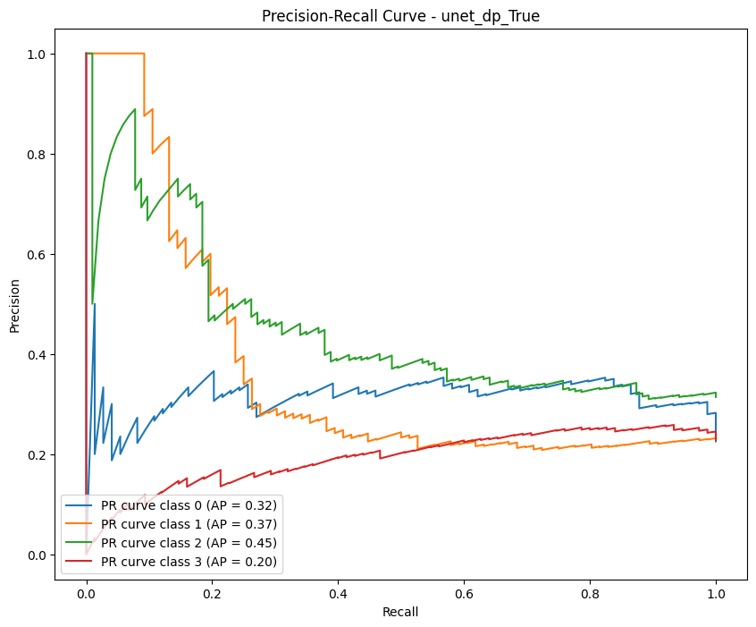

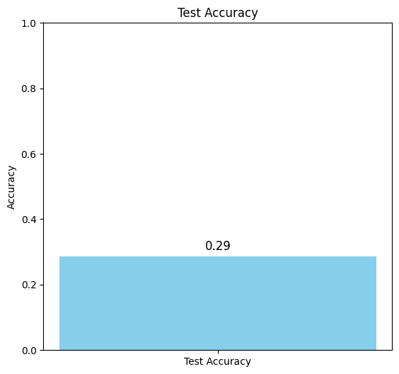

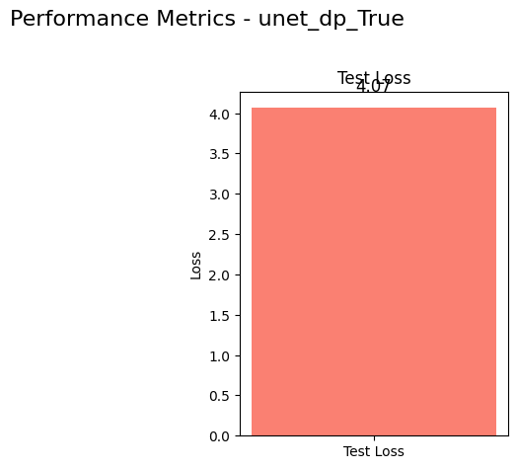

2. # Experiment parameters

num_classes = 3

num_clients = 5

num_rounds = 1000

model_name = 'unet'

use_dp = True

dp_params = {

'l2_norm_clip': 1.3,

'noise_multiplier': 0.1,

'num_microbatches': 1

}

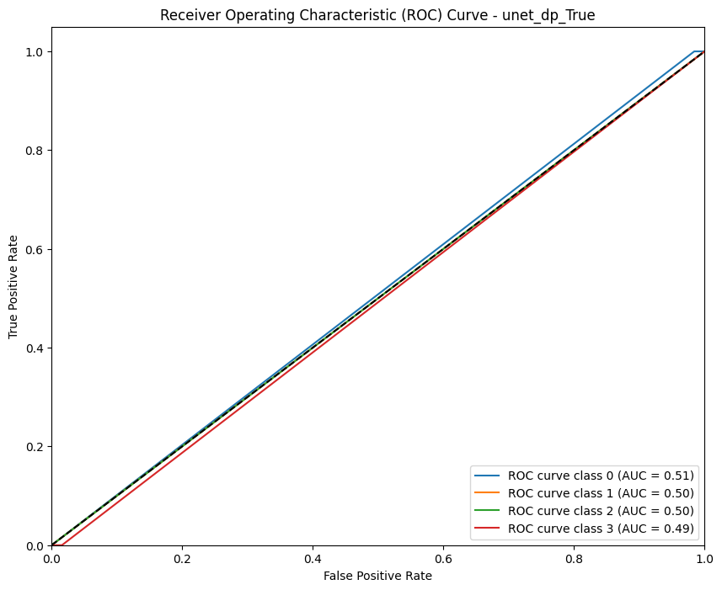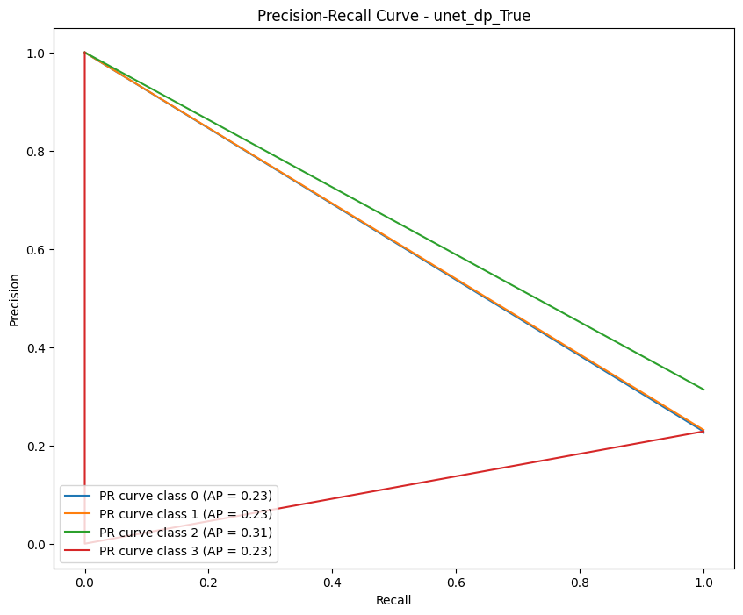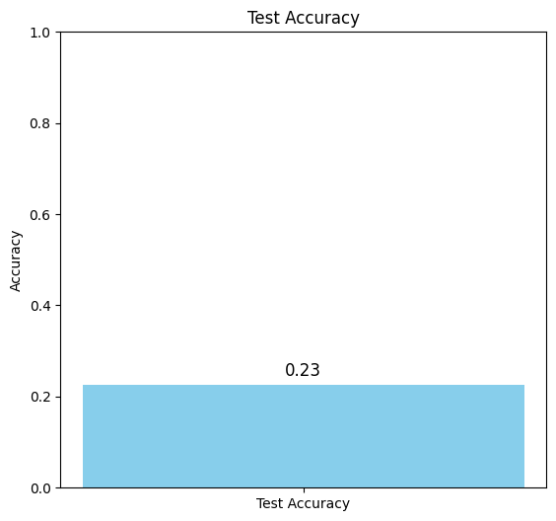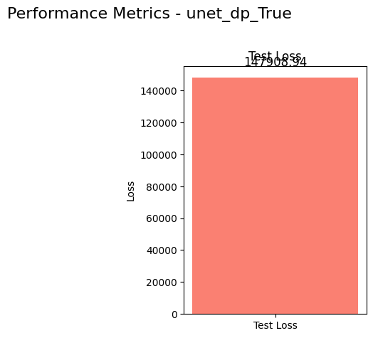

3. # Experiment parameters

num_classes = 3

num_clients = 5

num_rounds = 100

model_name = 'simple_cnn'

use_dp = True

dp_params = {

'l2_norm_clip': 1.3,

'noise_multiplier': 0.1,

'num_microbatches': 1

}

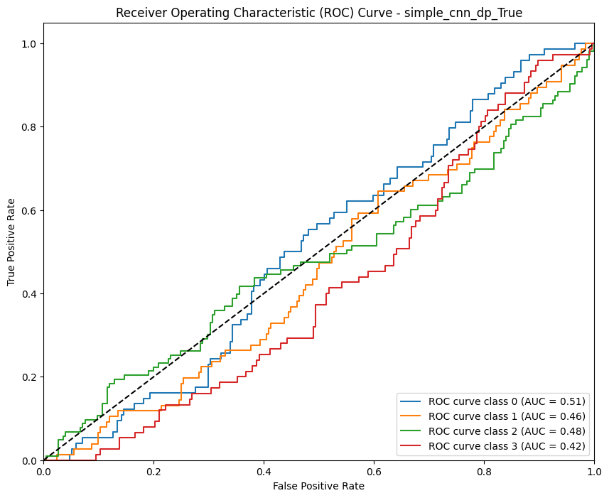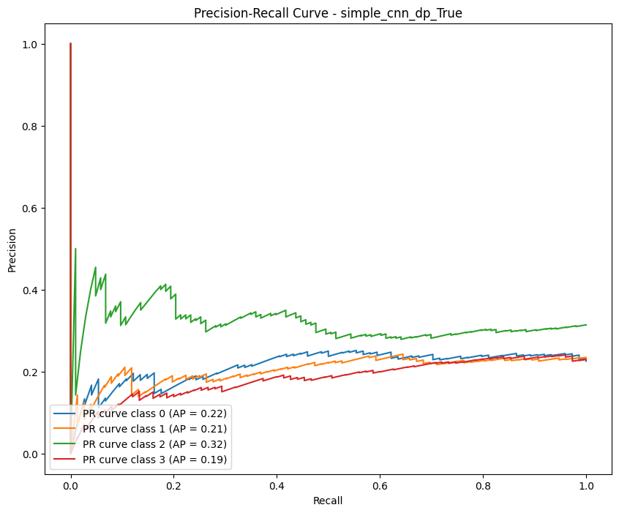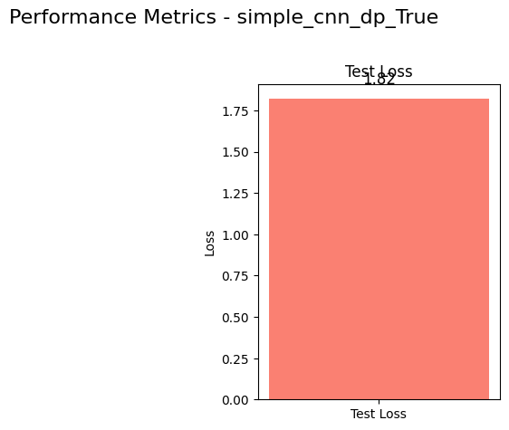

4. # Experiment parameters

num_classes = 3

num_clients = 5

num_rounds = 100

model_name = 'simple_cnn'

use_dp = True

dp_params = {

'l2_norm_clip': 1.1,

'noise_multiplier': 0.1,

'num_microbatches': 1

}

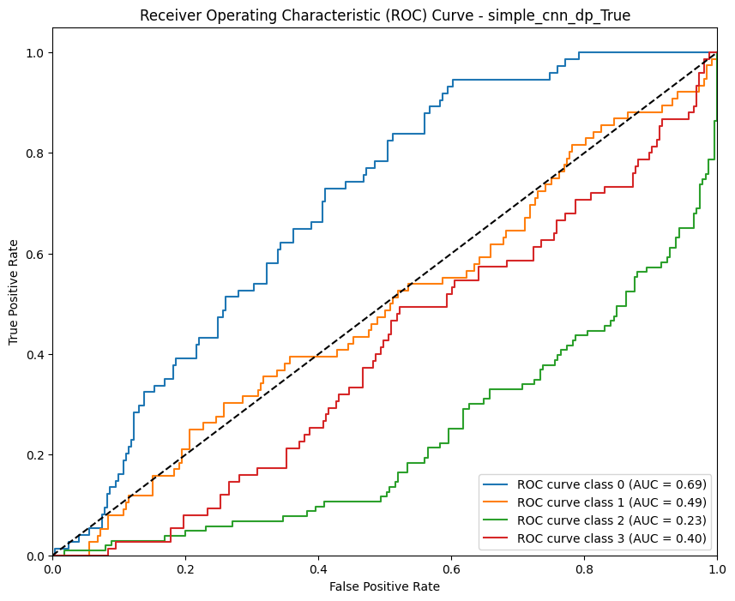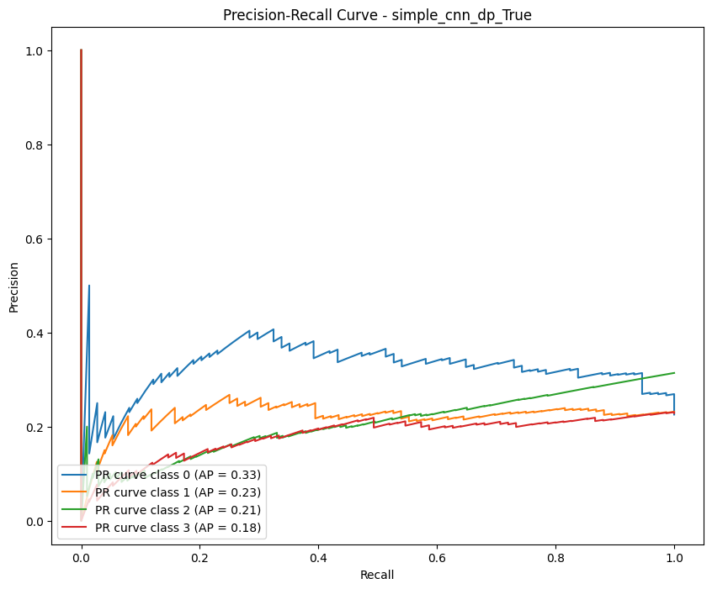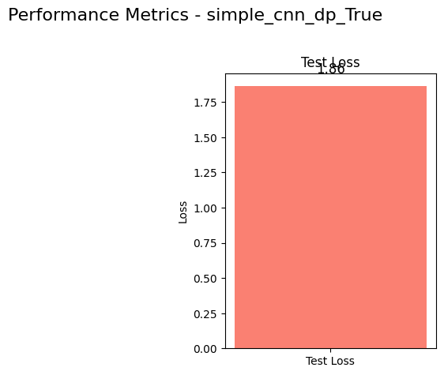

5. # Experiment parameters

num_classes = 3

num_clients = 5

num_rounds = 100

model_name = 'resnet'

use_dp = True

dp_params = {

'l2_norm_clip': 1.1,

'noise_multiplier': 0.1,

'num_microbatches': 1

}

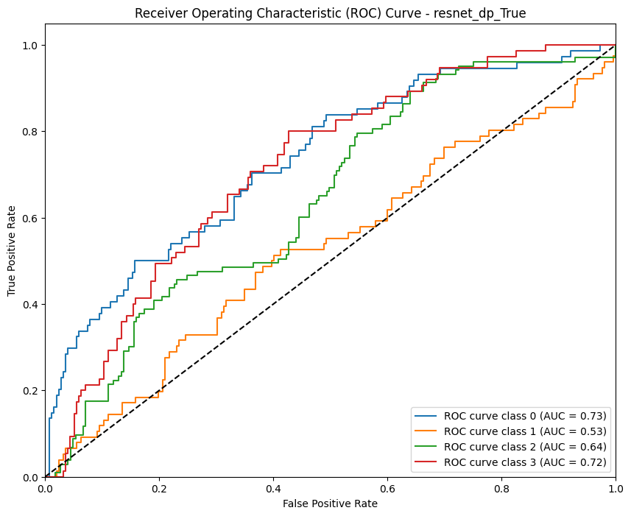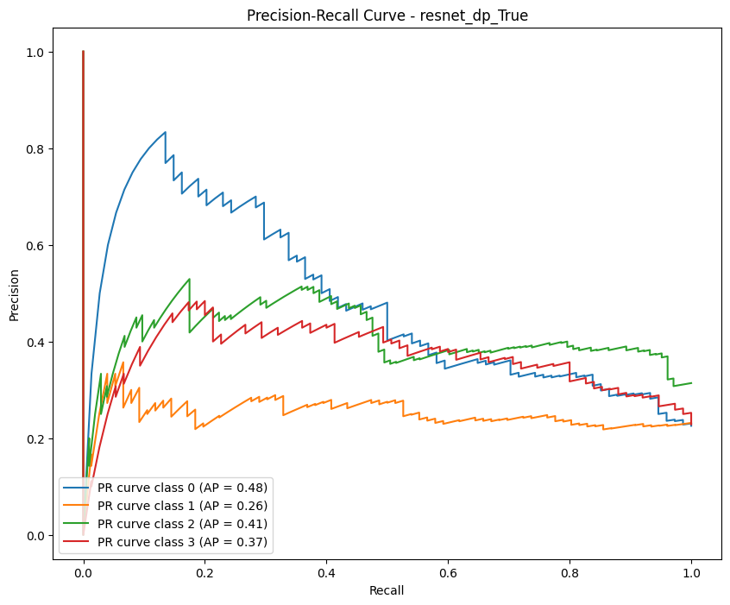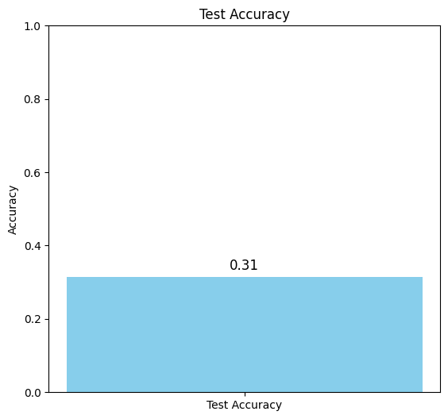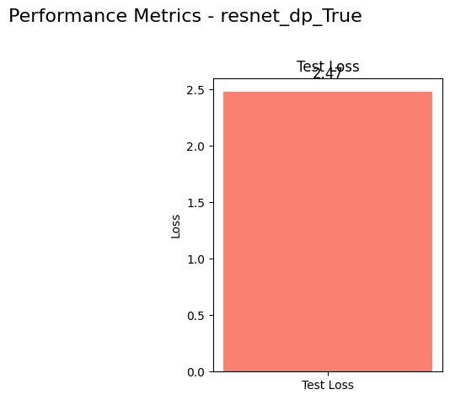

6. # Experiment parameters

num_classes = 3

num_clients = 5

num_rounds = 100

model_name = 'resnet'

use_dp = True

dp_params = {

'l2_norm_clip': 1.3,

'noise_multiplier': 0.1,

'num_microbatches': 1

}

